1.Install artemis in ur local machine

Go to bin folder and use my below command,where myLocalBroker is the folder name.

F:\sotfwares\apache-artemis-2.19.1\bin>**artemis create /myLocalBroker**

* Once command ran , then it will create some files in that above folder , go to the folder where u installed here it is **myLocalBroker**
* Inside we have a tool called **artemis** and then execute **run** command **on this**

**Example:**

**F:\myLocalBroker\bin> artemis run**

**Use crenetials as admin and pass as admin,**

**U will find console at http://localhost:8161/console**

You can now start the broker by executing:

"F:\myLocalBroker\bin\artemis" run

Or you can setup the broker as Windows service and run it in the background:

"F:\myLocalBroker\bin\artemis-service.exe" install

"F:\myLocalBroker\bin\artemis-service.exe" start

**To stop the windows service:**

"F:\myLocalBroker\bin\artemis-service.exe" stop

**To uninstall the windows service**

"F:\myLocalBroker\bin\artemis-service.exe" uninstall

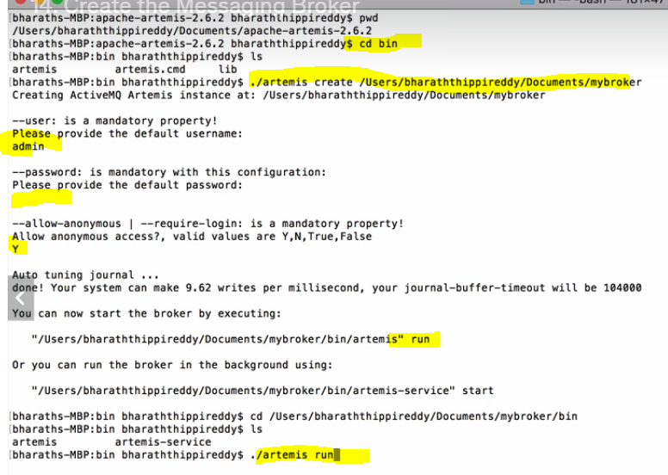

27.Prioritise messages

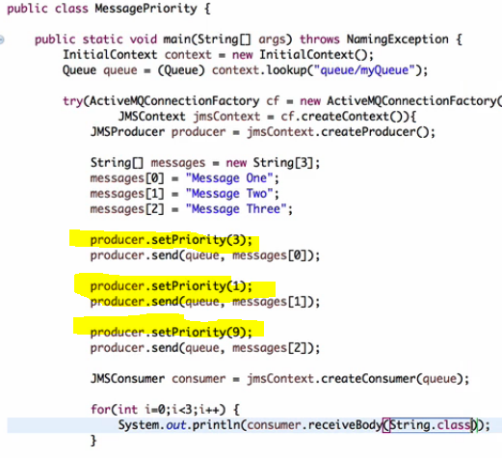s

30. Dynamically Replying to the Queue using header of the received message

While sending a message u set the header to which that consumer should respond.

Consumer, after receiving the message , he will check the header and reply to that

Real example:- in olden days, if u wanna reply to the letter, we will reply to the from address right

Same here, we have to set the header where it consist of the response queue.

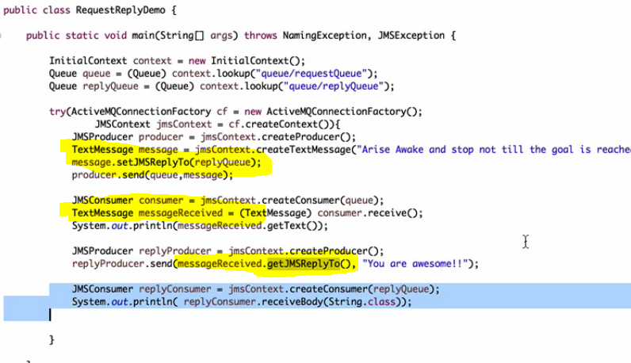

31.Replying to a temporary queue

Don’t create queue for replying , u can use temporary queues concept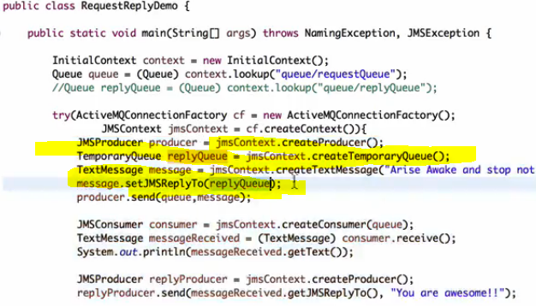

### Listening on a temporary queue

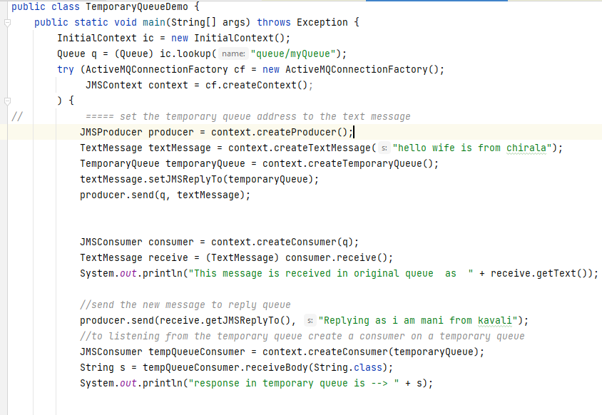

32.using co-relation id and message ID

Why?— **just to link the request and response**

See for every message , jms will provide an unique message ID

U will send a message and u will get the response and **if u want to know, the response is for which message** , then while sending the reply back , u should set the value for co-relation id field , this corelation better set same as message id u received

Note :- u cant set the message id ,but u can set the co relation id

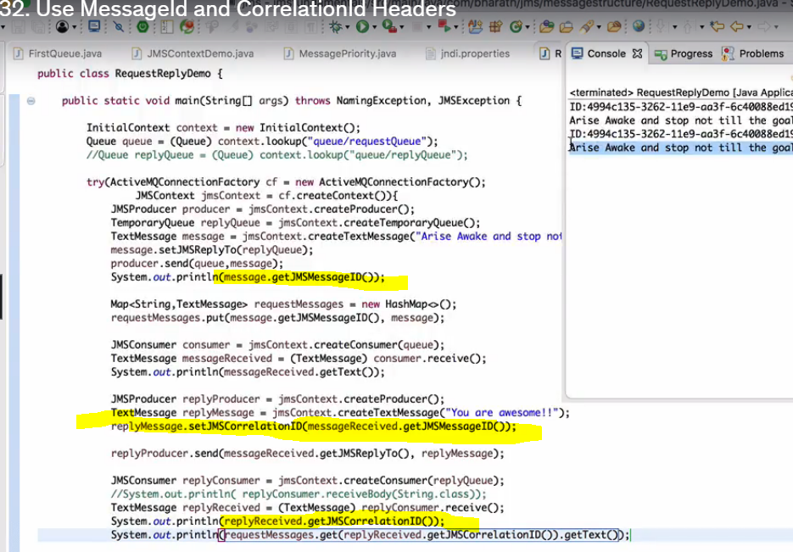

33. Set Message expiry

Once the message expired , u cant receive the message ,the expired msg will go to the expired queue.

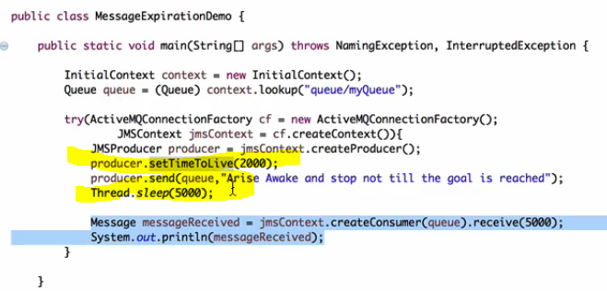

34.access expired msg

Expired messages are not lost , they were just moved to a separate queue called expiry queue, u can find the expired queue name in some xml file , and try fetching the message from there.

*To get the expired queue object , first decalre that entry in jndi.properties file*

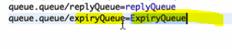

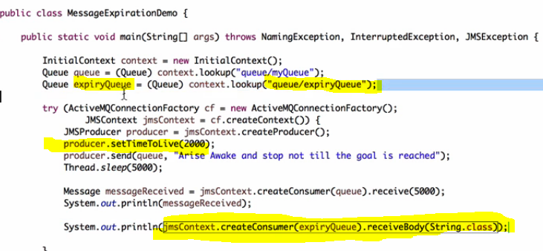

JMs Message anatomy

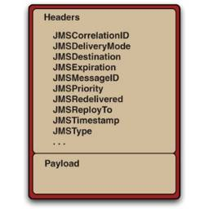

* JMS Message consist of mainly two parts **Headers** and **Pay-loads.**
* **Headers** consists of **metadata** of the message which is used by both clients and JMS Providers.
* **The Payload** consists of the actual body of the message (which can be binary or textual).
* The complexity of the JMS Message lies in headers.

35.Delay Message delivery

If u set this it will deliver after some time

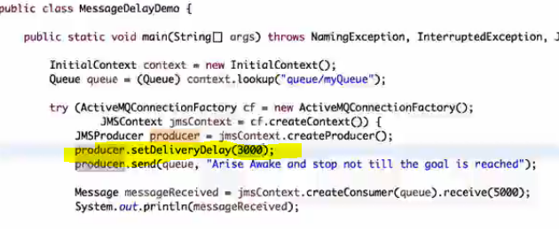

36.Set custom properties

0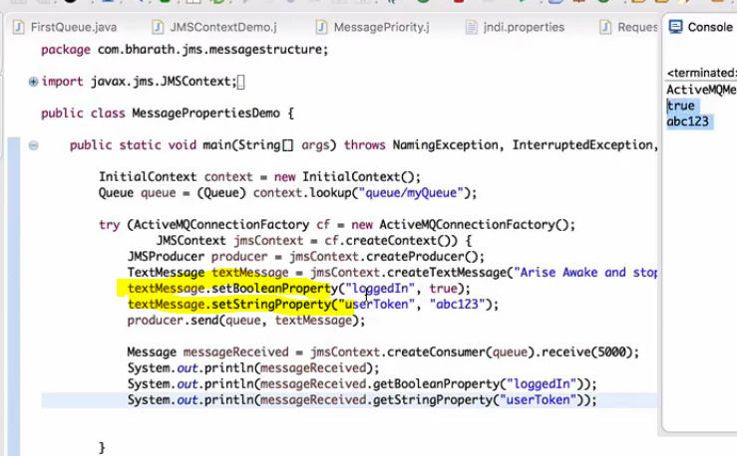

37.Message Types

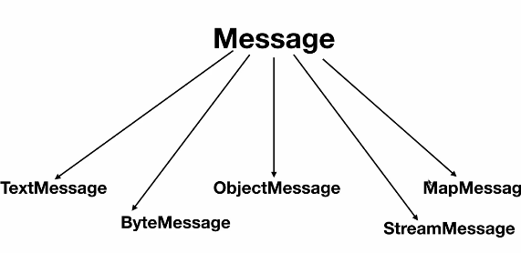

38.Message types in action

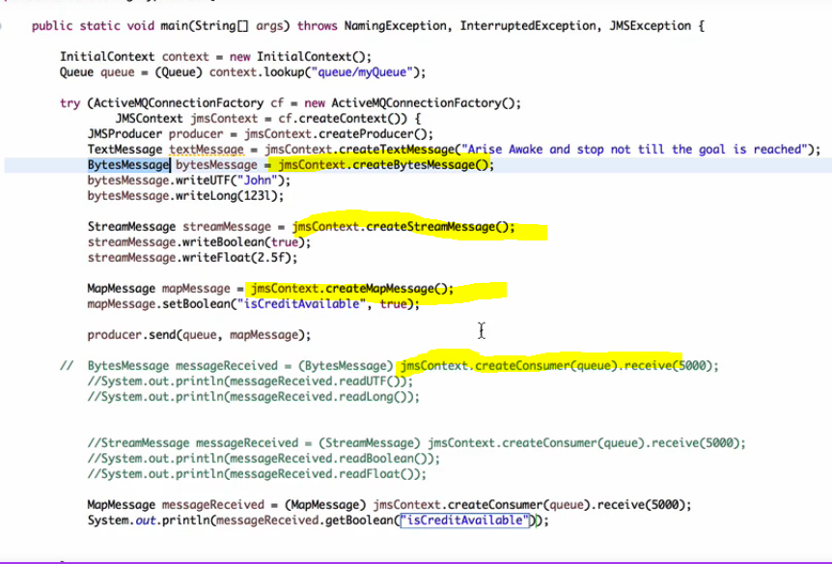

39.sending object to Queue

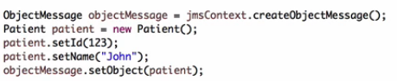

The advantage with above approach is , u can set the properties to the class ObjectMessage like replyTo …, actualy u can directly also send any object like below

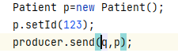

To receive – the below statement will wait for 5 seconds,if no msg it will exit

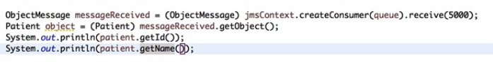

40. When to use P2P

In p2p , once a message is read , then that is lost

Use this when we have only 1 consumer.if 2 apps wants same data then go for pub-sub

We can increase the performance by increasing the numn of queues.

In p2p we have concept of QueueBrowser

Real use case :-

1)Amazon payment- when we made payment in amazon, we might be using a p2p model, the payment status success or failure will be kept in the response queue, reply queue and response queue may be different.

2) IRCTC ticket booking- generally it will communicate with many other,. The actual booking could be another service and it may reply via another response queue.

### **41.why asynchronous processing**

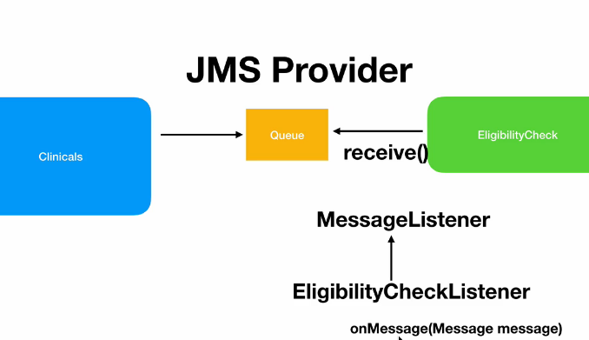

Problem is below is a blocking call.

Context.createConsumer(queue).receive(5000);

Whereas in async processing , we will be having a message listener, that will automatically be fired once msg arrived

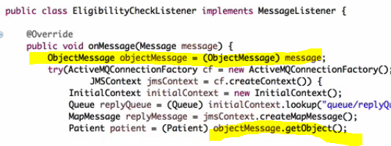

After creating consumer , its mandatory to attach listener

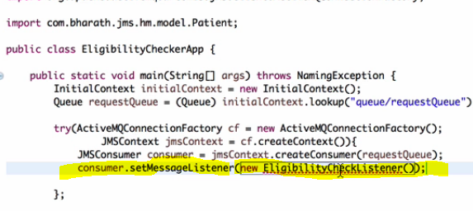

* **point-to-point model**: **Queues** are used as a destination in the point-to-point model. You can send and receive messages synchronously or asynchronously. **MessageConsumer.receive()** method is used to send messages synchronously to a consumer through queues.
* **MessageConsumer.setMessageListener()** method is used to receive messages asynchronously to a consumer through queues.
* At a time, only one consumer will be able to receive a message from the queue.
* In the above diagram, at a time only one message sent by the producer is sent to the queue, and the queue will send the message to only one consumer at a single time.
* JMS Provider uses **Round-robin** style to send a message across all the consumers.

42.Pub-sub model

When u want to tell the same information to many subscribers then go with topics

Put the message in topics,

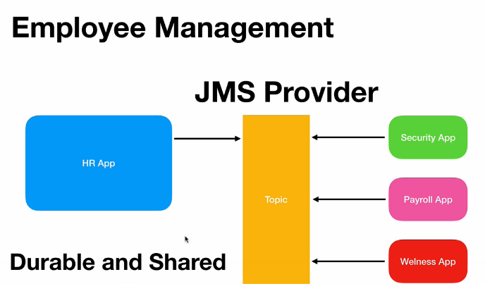

### Pushing to a topic

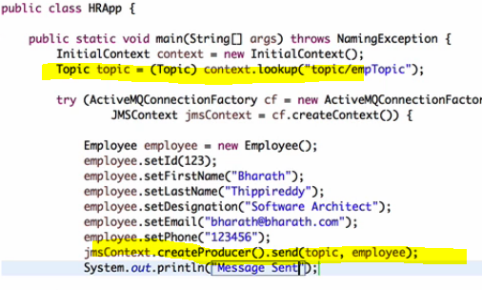

Consuming from a topic

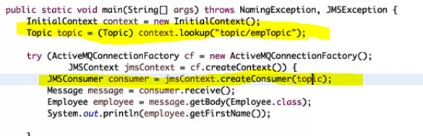

Durable subscriptions

When producer kept the message into the queue, if 1 among the 3 consumers went down, the message will still be preserved , once that consumer came online the message will be delivered

Once all the durable subscribers read the message , then only the message will be removed

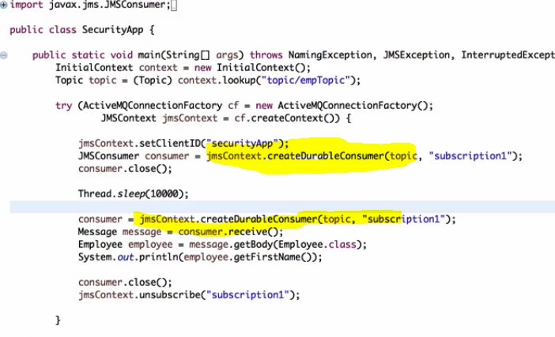

61.Filtering

Refer message filtering source code

**Use case:-**

Let say, on that queue , if 3 consumers are present ,if u put the message

Immediately it will go to any of the consumer, if u want that msg always go to consumer 1 , then apply the filters

Filters can be applied only on certain headers, not all headers

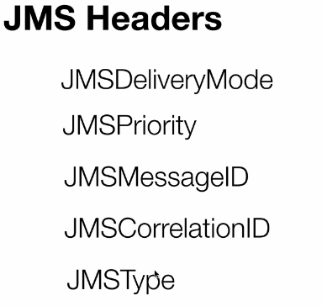

If u want to apply filtering , so that msg will always read by consumer 1

U can apply filters on headers not on payload

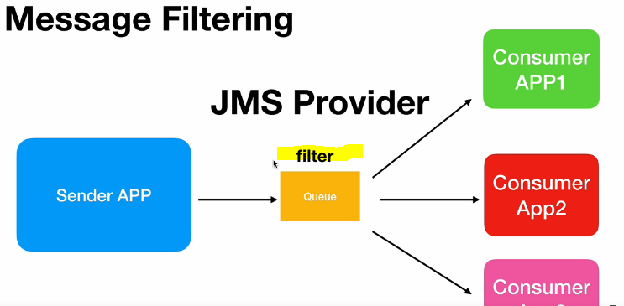

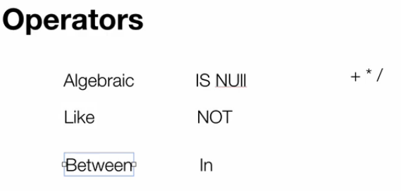

Setting header to the message

And while creating the consumer you should write the query

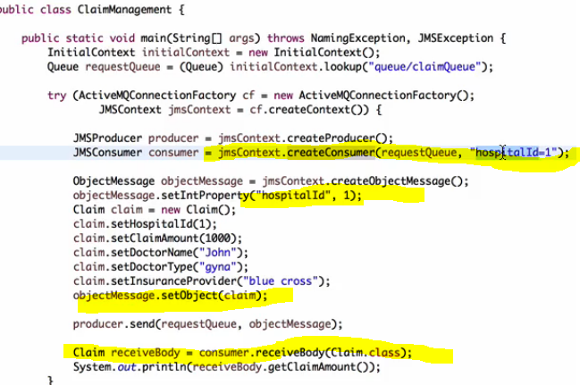

Other Operators

**Between:**

If those patterns didn’t matched , that consumer wont even pick, it will just remain in the queue

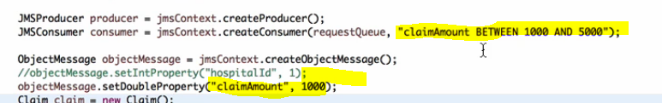

**Like operator**

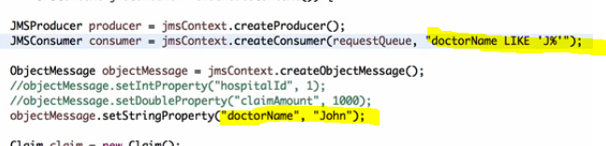

**Underscore**

Underscore represents single character

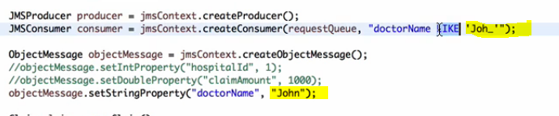

**In Operator**

**Setting a space in stringproperty is very dangerous, it will fail**

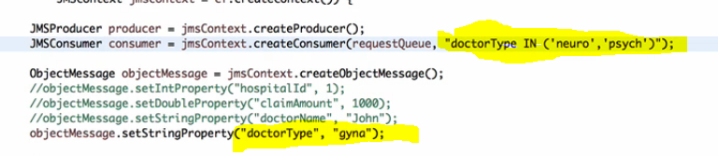

**Filtering by message priority**

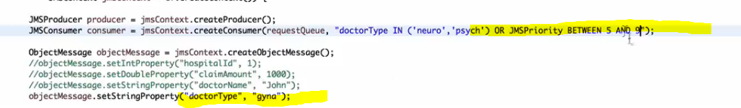

In the above case, message will not be picked up, because by default every message will have default priority of 4

Assignment

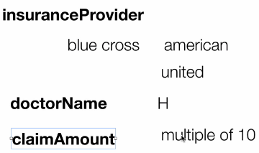

95.Spring JMS

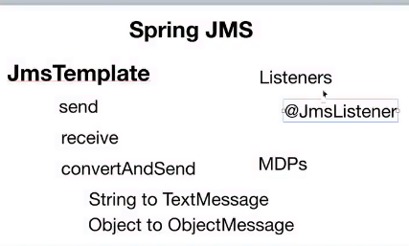

Add dependency

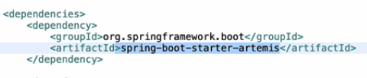

All projects source code is available in

<https://github.com/manideep-vv/JavaAllSubjectsNotes/tree/main/2.JMS/udemy%20bharath%20tippireddy%20notes-paint-example/jmsprojects/2.projects%20by%20bharath>

sending a message

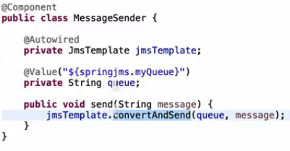

Creating a text message and sending

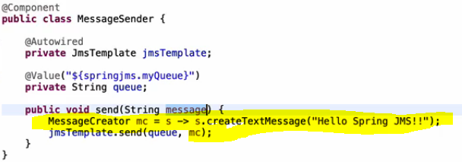

Providing properties

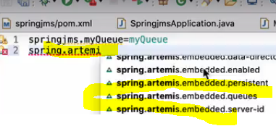

67.Guaranteed messaging

AUTO_Acknowledge

In this mode , producer.send () is a blocking call and it will wait until JMs server acknowledges as it is received correctly, in this mode , msg will be delivered only once

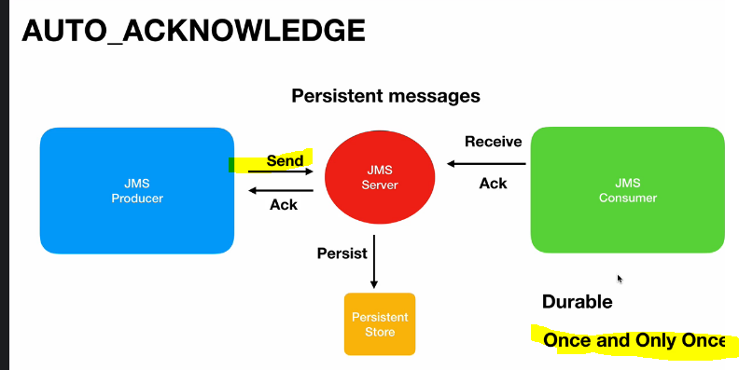

DUPS_OK_ACKNOWLEDGE

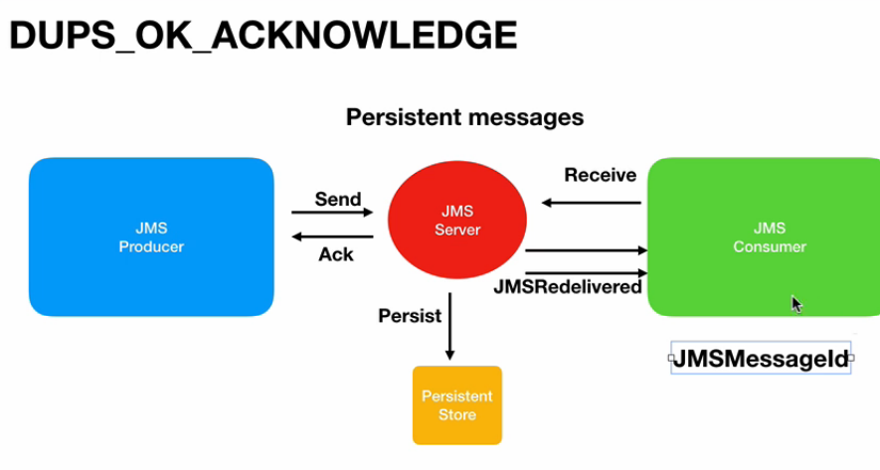

In this mode, the same message will be delivered again and again until it receives an acknowledgement

CLIENT_ACKNOWLEDGE

Until that particular message is acknowledged by using message.acknowledge(),that message will not be removed from the JMS server, this is almost similar to session transaction,

Only diff is there we will use jmsContext.commit() 🡪 committing all at once , here we have to say

Message.acknowledge() ; here we have to acknowledge for each and every message.

After sending the acknowledgement that single message will be removed from jms server

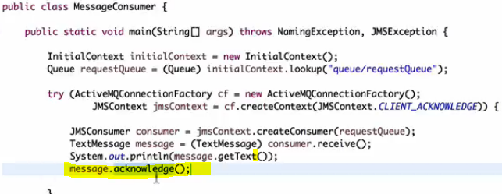

Real Time use cases

Use filtering concept

Lets say, if u have a queue and 3 consumers are listening , if any message arrives any consumer can pick , and if u want only 1 queue to pick up always , then use filter concept

So that create the consumer with filter and while sending the message add some headers

2) how will you identify if the msg received is a duplicate or not

Simple:- every message will be having an unique message id, u can store them in db which msg ids and all u have already processed.if the same msg with the same message id comes again better u can reject it.

Use transactions

Suppose if we want a response from consumer saying I (consumer) have received then use session transactions

Using acknowledgements

its best to prefer acknowledgements for each and every message, instead of transactions

Diff between transactions and client acknowledgement

In session transaction we are committing all at once, using context.commit()

Here we are committing for each individual message.

When the consumer has to say message.acknowledge(); then only the producer knows that has been delivered successfully, if u want these kind of acknowledgements then use client acknowledgement mode

If u want to send acknowledgements all at once use transactions,